1. Project Title and Group Members
Project Title: Macroinvertebrate Image Analysis System in Python
Group Members:
- u3331953 (Team Leader)
- u3302302
- u3315973

2. Brief Project Goal
The purpose of this project is to develop a Python-based application to find and analyse freshwater macroinvertebrates using the image-based data which is related to the classification, organisation, processing, visualisation, or analysis of macroinvertebrate image data. Freshwater macroinvertebrates are made of small aquatic organisms. Few of them are insect-larvae, worms, snails and crustaceans. They are mostly used in environmental and water-quality studies. This project aims to:
- design software using objects and classes
- process and manage data in a structured way
- apply Python libraries for solving practical problems
- show results clearly through outputs or visualisations
- make readable, maintainable, and well-documented code

3. Summary of the System Design
The system is made up of lots of parts that work together. This makes the system easy to work with and understand. The system is also easy to make bigger if we need to.
The project has three parts:
• Data Layer: This is where we load and store data. We also get the data ready to use
• Processing Layer: This is where we look at images and try to understand what is in them. We also try to figure out what the images are about.
• Presentation Layer: This is where users can see the results and interact with the system. It is like a window that shows us what is going on.
The system is designed so that each part has its job. This makes it easy to understand what each part of the Data Layer and the Processing Layer and the Presentation Layer does. The Data Layer and the Processing Layer and the Presentation Layer all work together to make the system work.

4. Class and Module Overview
The system is made up of a main part:
* DatasetLoader Class
This class is in charge of getting images and other information from the dataset.
* ImageProcessor Class
This class does things to the images to get them ready like making them smaller and turning them into grayscale and getting rid of noise. It uses OpenCV to do these things.
* EDAAnalyzer Class
This class looks at the data to see what is in it. Makes pictures to show things like how many of each type of thing there are and what some of the images look like.
* ClassifierModel Class
This class uses machine learning to figure out what kind of macroinvertebrates are, in the images and it can use types of machine learning like Scikit-learn or CNN.
* GUI Class, using Tkinter
This class makes a user interface that people can use to upload images run the analysis and look at the results.
Each ClassifierModel Class and DatasetLoader Class and ImageProcessor Class and EDAAnalyzer Class and GUI Class is designed to do one job, which makes the code easier to understand and work with.

5. Tools and Libraries Used
The following Python libraries were used to build this system:
• NumPy – used it for tasks and handling image data in arrays
• Pandas – helped to manage and prepare structured datasets
• OpenCV (cv2) – used it for tasks like resizing, filtering and changing images
• Matplotlib – used to create visuals when exploring data
• Seaborn – helped to create better statistical visuals
• Scikit-learn – used to build machine learning models for classification
• Pillow (PIL) – helped to load and handle different image formats
• SciPy – used it for complex numerical tasks and data processing
These libraries were chosen because they are efficient, reliable and good for data analysis and image processing tasks like NumPy for numerical tasks Pandas for data management and OpenCV, for image processing.

6. Key Features Implemented
The system includes the following key features:
- Image loading and preprocessing
- Exploratory Data Analysis (EDA) with visualisations
- Classification of macroinvertebrate species
- Graphical User Interface for user interaction
- Display of prediction results and insights
These features allow users to analyse and interpret macroinvertebrate data effectively.

7. Screenshots or Example Outputs
The following outputs demonstrate system functionality:
- Dataset visualisation graphs (class distribution)
- Sample processed images
- Classification results displayed in GUI
- User interface screens
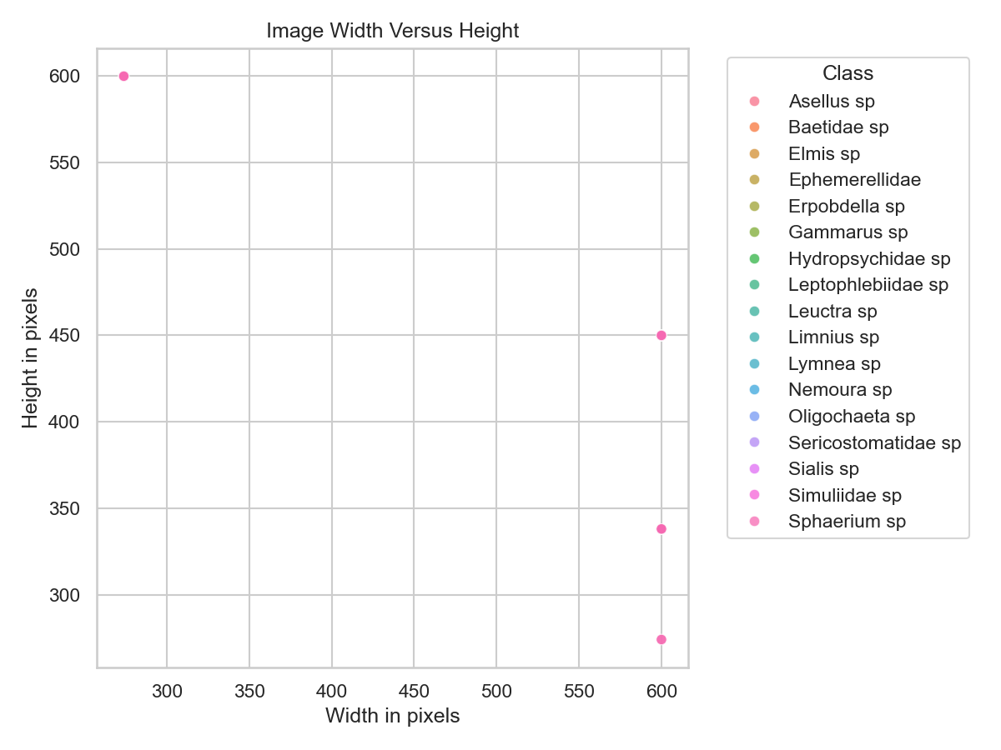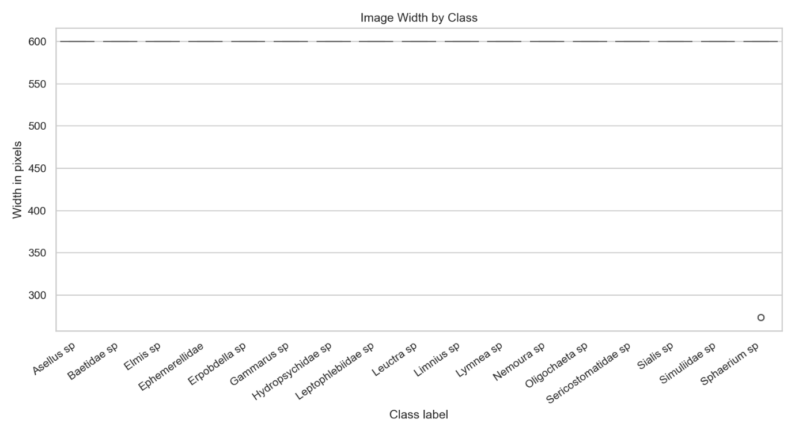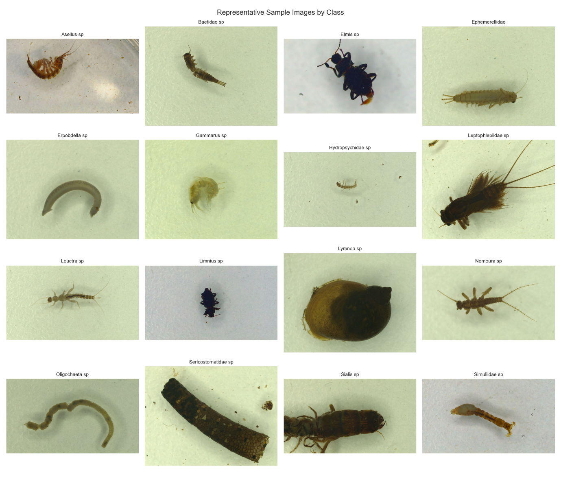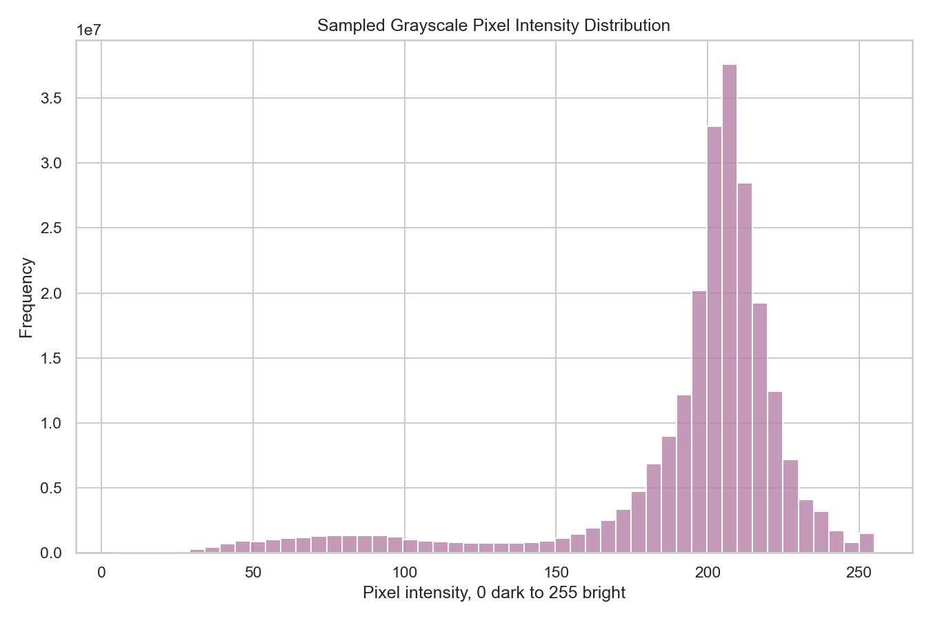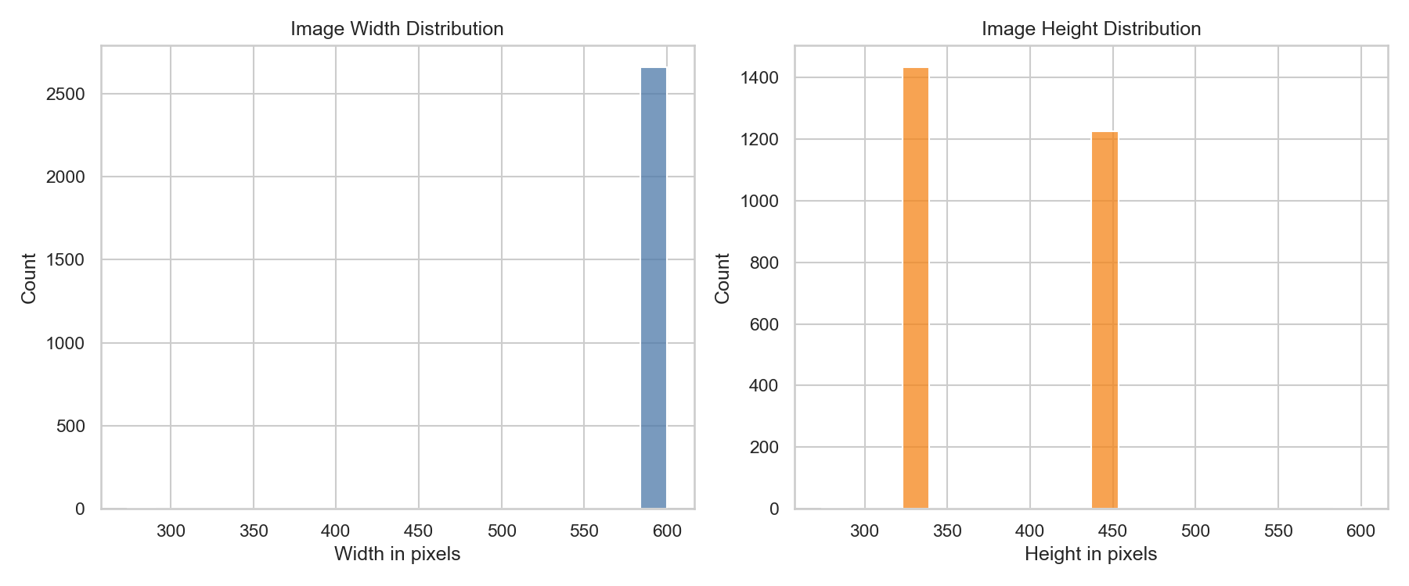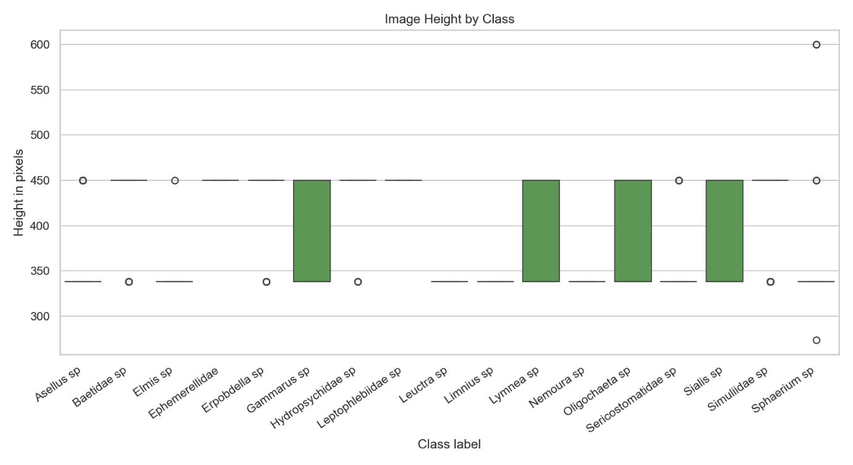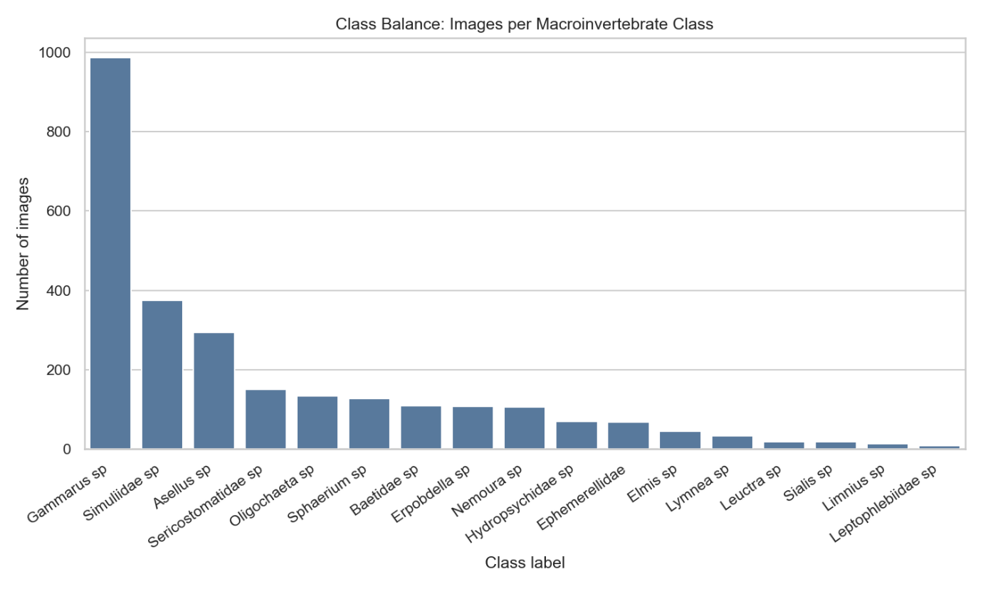
8. Testing Summary
The system was tested to ensure correctness, reliability, and usability.
Testing included:
- Functional Testing: Verified each module performs expected tasks
- Input Testing: Tested with different image inputs and dataset variations
- Edge Case Testing: Handled missing or corrupted image data
- GUI Testing: Ensured smooth user interaction and correct output display
All major features were tested and produced expected results.

9. Acknowledgement of Reused or Adapted Code
Some components of the project were adapted from unit tutorials and lab materials, particularly:
- GUI implementation using Tkinter
- Basic data processing techniques using Pandas
- Visualisation examples using Matplotlib
These code segments were modified and extended to fit the project requirements. All reused code has been clearly acknowledged in the source code comments and integrated into the overall system design.

10. Work Division
The work was distributed among group members as follows:
- u3302302 & u3315973: Data handling and EDA implementation
- u3331953: GUI development, testing, and system integration
All members collaborated during design, debugging, and final integration to ensure a consistent and functional system.

